**WebMUO Readme**

**1) Overview**

WebMUO is designed to help administrators manage and showcase their Ultima Online shard through a modern, dynamic website. It offers players a real-time view of the server while giving admins full control over how their shard is presented online. It’s built to be simple, reliable, and flexible, no technical experience required beyond basic server setup.

**Admin Panel Summary**

The admin panel puts full control of the shard website into the administrator's hands. Whether updating visuals, sharing downloads, managing navigation, or posting updates, everything can be done quickly and securely, all from the browser. No file editing or coding skills required.

**Admin Login**

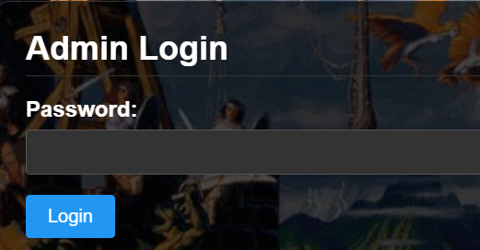

The Admin Login is a gateway to the website’s management panel. It requires a password to access, ensuring that only authorized shard administrators can modify settings, update content, or customize the site’s appearance. Once logged in, admins gain full control over the shard’s web presence through an easy-to-use interface. You can access the login page @ yourdomain.com/admin.php. The admin password manages in the config.php file.

**Site Appearance**

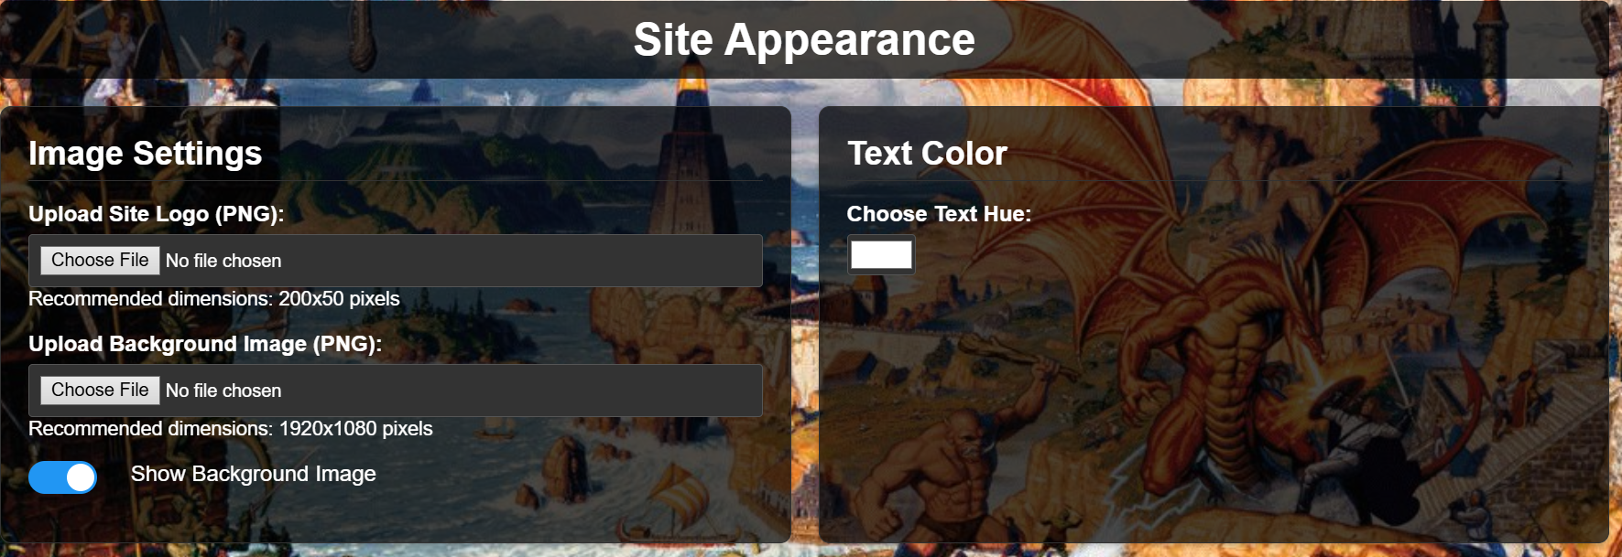

The Site Appearance section lets administrators customize the look and feel of the website. It includes options to upload a custom site logo and background image, toggle the background display on or off, and choose a text hue to match the shard’s aesthetic.

**Homepage Configuration**

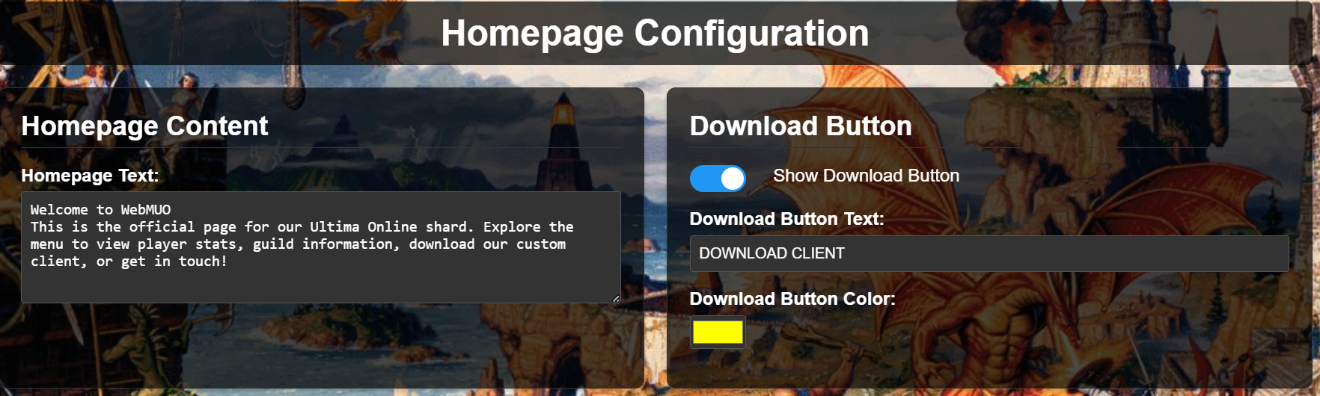

The Homepage Configuration section allows administrators to customize the main landing page. It includes editable homepage text for welcoming players and a toggleable download button with customizable label and color.

**Client Configuration**

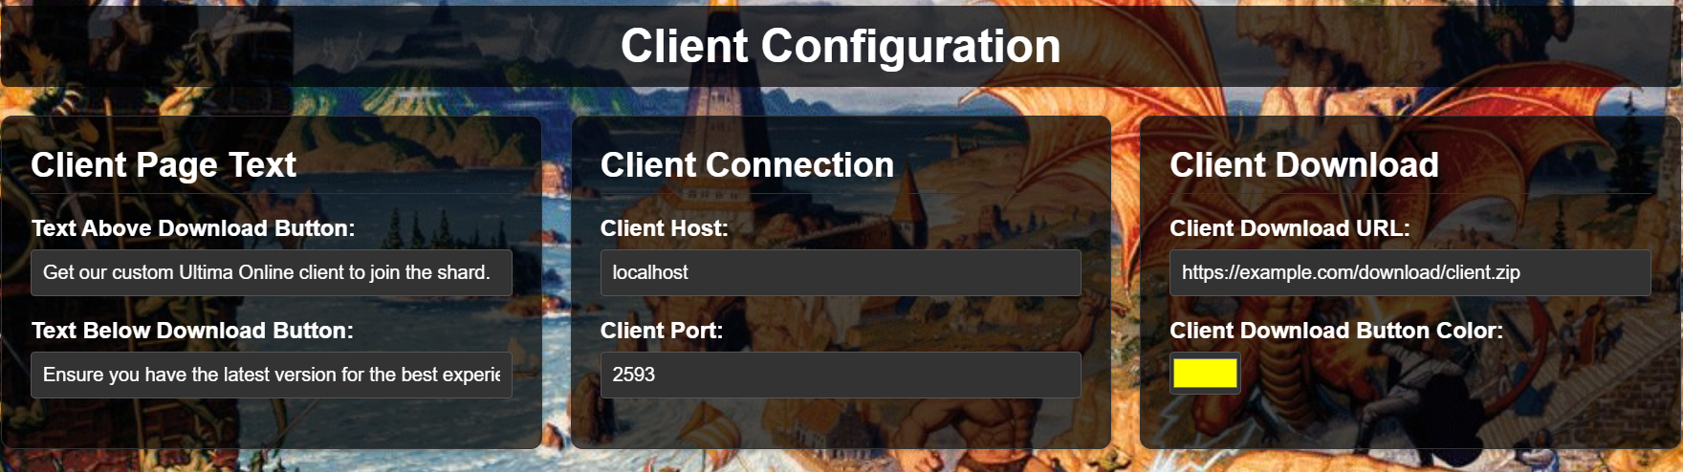

The Client Configuration section manages how players connect to the shard and download the game client. Admins can set the client host and port, provide a direct download URL, and customize the text and color around the download button.

**Navigation & Social Links**

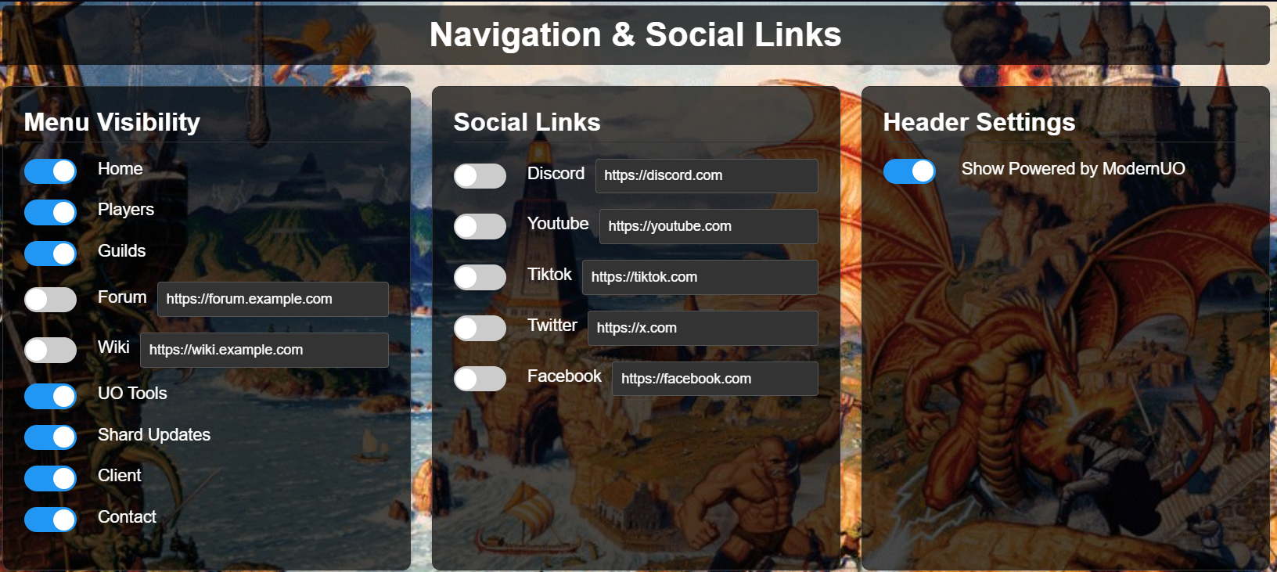

The Navigation and Social Links section lets administrators control which pages appear in the site’s main menu and footer. Admins can toggle visibility for sections like Players, Guilds, Forum, Wiki, and more. It also allows adding custom links to social platforms such as Discord, YouTube, TikTok, Twitter, and Facebook. The header setting allows you to show/hide the “Powered by ModernUO” object on your site.

**Footer Settings**

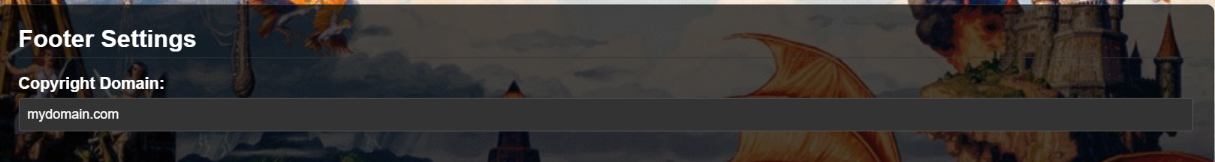

This setting allows you to change the site URL on the page footer next to copyright

**Manage Contact Info**

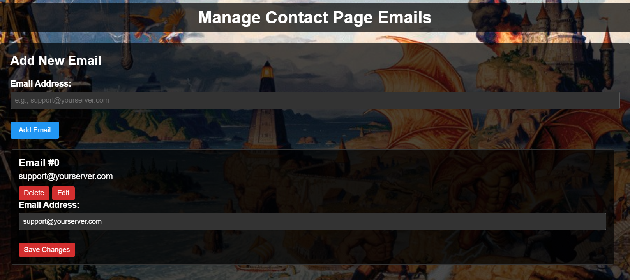

The Manage Contact Page Emails allows you to set the shards email contact addresses

**Manage UO Tools**

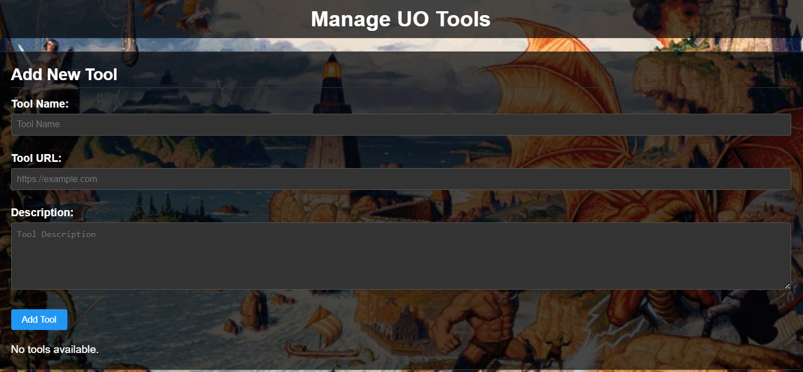

The UO Tools section allows administrators to add helpful external resources for players, such as macros, guides, or launcher downloads. Each tool includes a name, URL, and description, and appears on the public UO Tools page.

**Manage Shard Updates**

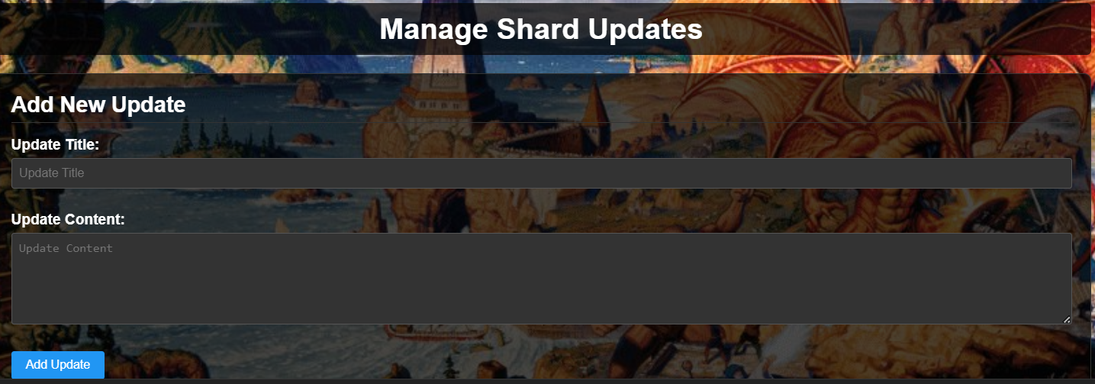

The Shard Updates section lets administrators post news, patch notes, or announcements directly to the website. Each update includes a title and message, and appears on the public Shard Updates page when enabled. It’s a simple way to keep players informed about changes, events, or important updates related to the shard.

**Setup**

1) Unzip to WebMUO zip file to a directory somewhere on your computer. There will be 2 files inside named “Scripts” and “Web”

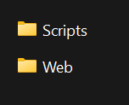

2) Copy the “custom” folder to your ModernUO projects folder located at ModernUOdirectory\Projects\UOContent or wherever your custom scripts reside.

3) Copy the contents of the “Web folder” to your domains root directory or the root directory of the web path you want your site to reside.

4) Open WebMUOExporter.cs and around line 28 edit the domain name to match your domains root directory for your site for example if your site were modernuo.com you your use <https://modernuo.com/config.php>. This tells ModernUO where to find the config file and upload the site files to.

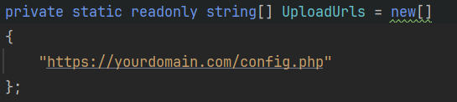

5) Create a sql database, directions vary depending on your hosting service. Here is a generic overview but its best to lookup instruction for your particular host if you are not familiar with the cpanel on your domain.   
  
 **Log into your hosting control panel (cPanel)**

* Go to yourdomain.com/cpanel
* Enter your hosting username and password

**Open the MySQL® Databases tool**

* Scroll down to the **Databases** section
* Click **MySQL® Databases**

**Create a new database**

* Under **Create New Database**, enter a name (e.g., uo_web)
* Click **Create Database**

**Create a new MySQL user**

* Scroll down to **MySQL Users**
* Enter a **Username** (e.g., uoweb_user) and **Password**
* Click **Create User**

**Add the user to the database**

* Under **Add User to Database**
  + Select the user and database you just created
  + Click **Add**
* On the next screen, check **All Privileges**
* Click **Make Changes**

**Save your database credentials**

* You’ll need these for your website config:
  + **Database Name**
  + **Username**
  + **Password**
  + **Database Host** (usually localhost)

Once your database is setup edit the config.php file that you copied to your domain directory. Fill in your database credentials.

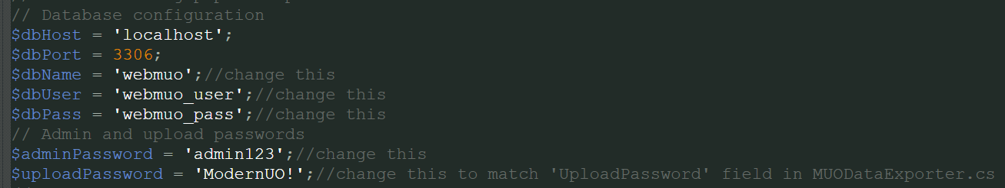

**(Data Base Information)**

$dbHost = 'localhost'; (This usually does not need editing)

$dbPort = 3306; (This is the common port for sql)

$dbName = 'webmuo';//change this This will be your Data Base “Name”

$dbUser = 'webmuo_user';//change this Data Base “User”

$dbPass = 'webmuo_pass';//change this Data Base Password

**(Admin Page Password)**

// Admin and upload passwords

$adminPassword = 'admin123';//change this

**(Upload Authentication Between ModernUO and Web Host)**

$uploadPassword = 'ModernUO!';//change this to match 'UploadPassword' field in MUODataExporter.cs

Once these are set up re compile and start your ModernUO Server and the files for the site will be generated in ModernUO\Distribution\wwwroot and automatically uploaded to your site. Your database tables will be written and your site should be up and running when you navigate your browser to [**https://yourdomain.com/index.php**](https://yourdomain.com/index.php)

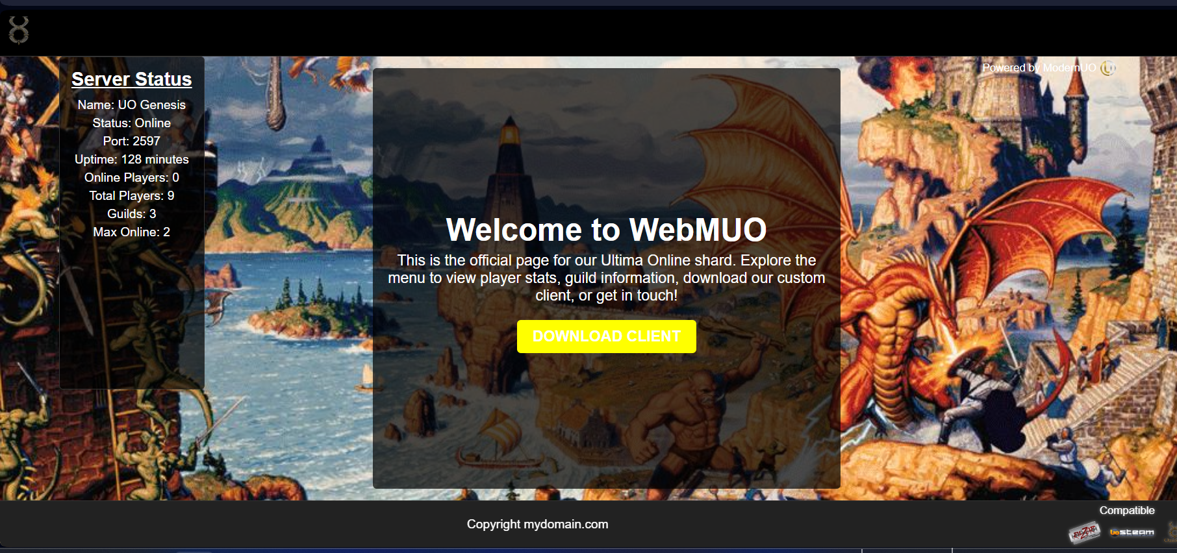

You should be presented with the main page. You should see your servers live status on the left panel under the “Server Status” panel. Your menu will be hidden by default so you will need to login to the admin page to begin setting up your shards site.

Navigate to your admin login page [**https://yourdomain.com/admin.php**](https://yourdomain.com/admin.php)

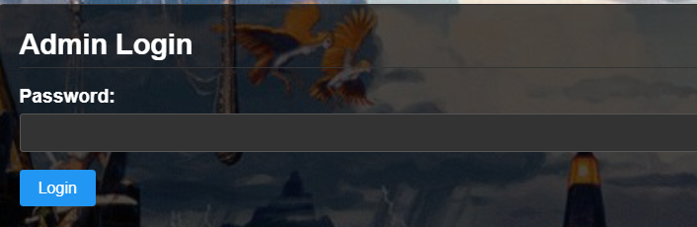

Enter the password you set up in the config.php file. If you haven’t changed the password the default password is “admin123”

If the login is successful you will be presented with the Admin Dashboard

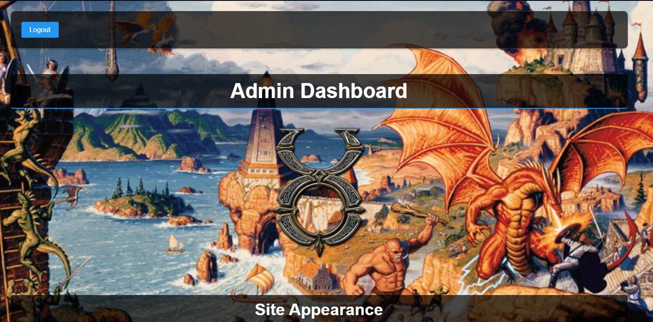

You are all set to begin adding your sites details and customizing the site.

**Troubleshooting**

If you are having issues, check the logs located at ModernUO\Distribution\Logs for further information on what exactly is causing the problem. It will be in the muo_data_export.log file.

